Breaking Down the Generative AI Application Ecosystem  
  
While generative AI applications might offer a straightforward user experience, the backend is anything but simple. Here's a snapshot of what it takes to launch and maintain a generative AI system:  
  
🔵 𝗙𝗿𝗼𝗻𝘁𝗲𝗻𝗱: This layer is where users interact with AI through interfaces like chatbots or via web and app platforms that host these services.  
  
🟢 𝗢𝗿𝗰𝗵𝗲𝘀𝘁𝗿𝗮𝘁𝗶𝗼𝗻: This critical layer coordinates various services, ensuring that user requests are processed correctly and efficiently.  
  
🔴 𝗕𝗮𝗰𝗸𝗲𝗻𝗱: It includes databases and caching systems like Redis and SQLite, crucial for storing and quickly retrieving data to keep the AI responsive.  
  
🔷 𝗔𝗣𝗜𝘀 𝗮𝗻𝗱 𝗛𝗼𝘀𝘁𝗶𝗻𝗴: Services that offer APIs for proprietary and open-source AI models, allowing developers to integrate AI capabilities into their applications.  
  
🛠️ 𝗧𝗼𝗼𝗹𝘀: A suite of tools is necessary for creating prompts, embedding models, validations, and developer plugins that enhance the functionality and reliability of AI applications.  
  
🌐 𝗜𝗻𝗳𝗿𝗮𝘀𝘁𝗿𝘂𝗰𝘁𝘂𝗿𝗲: The underlying hardware and cloud services that provide the necessary computing power to run AI models, such as GPU instances.  
  
Despite the seamless experience on the front end, the backend is a complex combination of services and infrastructure.  
  
Each component must work in concert to provide the functionality we often take for granted.  
  
Photo Credit - @tingyi-le

Activate to view larger image,



Today, I am sharing an updated list of free AI courses that are perfect for anyone looking to enter the AI field.  
  
These resources have been incredibly helpful in my own learning journey, and I believe they can offer valuable insights to you too.  
  
For professionals aspiring to demystify AI in 2024 and acquire a comprehensive understanding, the following resources are recommended:  
  
- AI Essentials: [lnkd.in/dyEt4DGt](http://lnkd.in/dyEt4DGt)  
- ChatGPT Mastery: [lnkd.in/eiRtk-6q](http://lnkd.in/eiRtk-6q)  
- Google AI Magic: [lnkd.in/eBQXfBe9](http://lnkd.in/eBQXfBe9)  
- Introduction to AI by Harvard: [lnkd.in/eu4mZaAG](http://lnkd.in/eu4mZaAG)  
- Microsoft AI Basics: [lnkd.in/eYNWzXUX](http://lnkd.in/eYNWzXUX)  
- Prompt Engineering Pro: [lnkd.in/eNi_YNSe](http://lnkd.in/eNi_YNSe)  
- Google's Ethical AI: [lnkd.in/eTrwSU89](http://lnkd.in/eTrwSU89)  
- Machine Learning by Harvard: [lnkd.in/eX28syMJ](http://lnkd.in/eX28syMJ)  
- Understanding Language Models by LangChain: [lnkd.in/evZVJbNy](http://lnkd.in/evZVJbNy)  
- Bing Chat Applications: [lnkd.in/ejN-qrVy](http://lnkd.in/ejN-qrVy)  
- Generative AI by Microsoft: [lnkd.in/dqjnzcCD](http://lnkd.in/dqjnzcCD)  
- Amazon's AI Strategy: [lnkd.in/dFhmsvZC](http://lnkd.in/dFhmsvZC)  
- AI for Everyone: [lnkd.in/eFx7zCz7](http://lnkd.in/eFx7zCz7)  
- AWS AI Foundations: [lnkd.in/dEjN9PRm](http://lnkd.in/dEjN9PRm)  
  
Stay tuned for more educational content and follow my professional journey for updates - [Brij kishore Pandey](https://www.linkedin.com/in/brijpandeyji/)

[[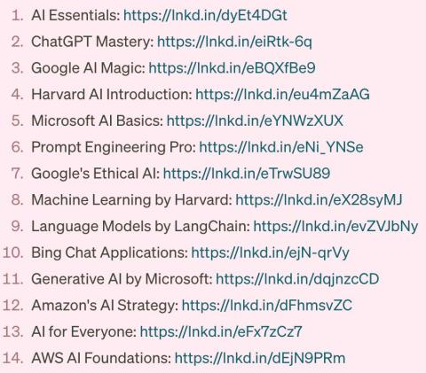](https://www.linkedin.com/feed/)](https://www.linkedin.com/feed/)